Appendix:

Land Management Plan Brief – Glenrigh and Callart

Contents

1. Key Background Information
2. Strategic drivers
3. Draft Land Management Plan Objectives
4. Stakeholders

1. Key background information

Introduction

This land management plan will review and replace the previous Forest Design Plans of Glenrigh (030/519/151) and Callart (030/519/032) and combine them into a single plan: Nether Lochaber Land Management Plan. This LMP will cover two existing forests, Glenrigh (2078ha) and Callart (288ha) for a total area of 2366ha across open ground and forest.

Glenrigh is predominantly a softwood conifer production forest with some areas of ancient woodland and priority open habitat restoration. Most of the plantable areas have been stocked although there is potential for some woodland creation.

Callart has been identified as an excellent candidate for PAWS restoration. Softwood conifer production is scaling down as the forest moves back to native woodland and productive broadleaves.

Silvicultural Potential

Within Glenrigh Forest, elevation ranges from sea level at the Loch Linnhe car park rising to 615m near Creag Bhreac and 616m at Beinn na Gucaig. There are existing areas of open ground or sparse vegetation that may be suitable for woodland creation of both commercial conifers and productive broadleaves. Much of the forest, especially the higher ground, is moderately or severely exposed to the prevailing southwest winds which funnel up Loch Linnhe and into Glenrigh. Reducing the rotation length for conifer crops to 40-45 years can mitigate the high risk of windblow in many parts of the forest and will be balanced with commercial requirements.

The soils and site conditions widely favour Sitka/Norway spruce production, although there is scope for other alternative conifers such as Douglas fir, Scots pine, and Pacific silver fir. Clearfell/restock will be the primary silvicultural prescription for most of the coupes, although there are opportunities for continuous cover forestry. Group selection or single tree can help to diversify the current stand age classes. Over time this gives the impression of a more structurally diverse late seral (‘old growth’) forest, which enhances visitor experiences and provides abundant habitat for wildlife.

Within Callart Forest, elevation ranges from approximately 10m above sea level near Allt an Daraich rising to approximately 400m above Allt Call-ort Na Gobhlan. The forest has low to moderate exposure to the prevailing southwest winds, rising with elevation. Outside of ancient woodland areas, this forest has good potential for coupes of productive broadleaves such as sycamore or oak on the lower slopes and birch in the uplands. Given the adequate road access, generally fertile soils, south-facing exposure, and gentle slopes, the lower reaches of the forest may be suitable for oak sawlog production.

Climate change models suggest that the climate will become generally warmer, with drier summers and wetter winters. This suggests an increase in productivity, especially in Sitka/Norway spruce dominated crops. However, the frequency and intensity of Atlantic storm systems is expected to increase as well, with a corresponding effect on windblow potential.

Land Use and Existing Crop

Within Glenrigh woodland accounts for 45% of the total area, with an additional 6% currently felled and awaiting restock. Open ground covers 34% of the forest, with another 13% designated as agriculture (grazing lets) and 1% unplantable or bare. Other land uses covering less than 1% are shown in the pie chart below.

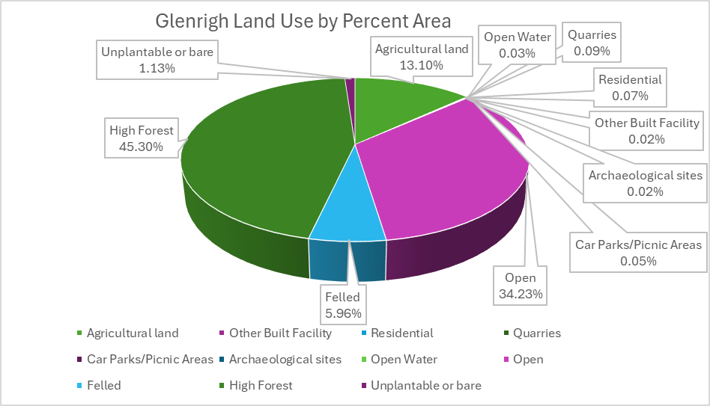

Of the woodland cover within Glenrigh, 55% is currently mature or older forest. Less than 20% is thicket or establishing crop. Considerable restructuring of the forest should continue to achieve a more proportional ratio of age classes.

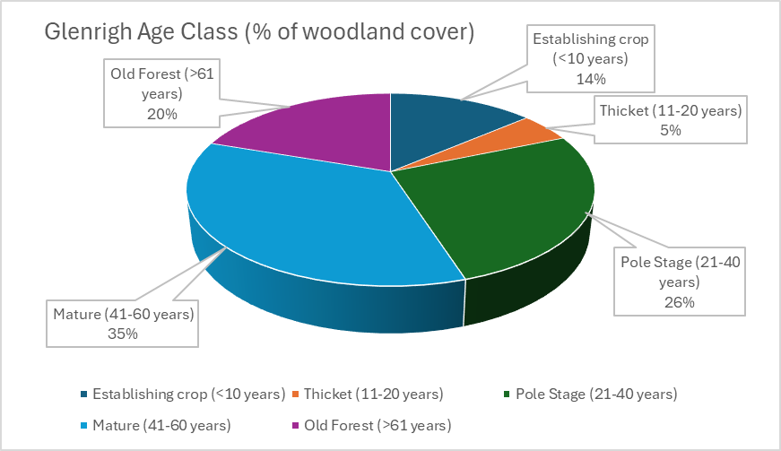

Species composition within Glenrigh is dominated by Sitka spruce, which accounts for over two-thirds of the total woodland cover. Lodgepole pine comprises an additional 14% while all other species each make up less than 5% of woodland cover. Species diversification will continue as more riparian areas become wooded with broadleaves and alternative conifers for production are considered.

Within Callart, woodland cover accounts for nearly 60% of the land use with an additional 19% felled and 16% open ground. A small amount of unplantable or bare land also exists, mainly in the craggy slopes above Coille Chanuis.

Of the woodland cover in Callart, 55% is old forest (61+ years) but there is 0% mature crop (41-60 years). 33% of the forest is pole stage with another 4% and 8% for thicket and establishing crop, respectively. Significant restructuring of the forest should be undertaken to achieve a more proportional ratio of age classes.

Species composition within Callart is varied, with 60% Sitka/Norway spruce and over 20% Silver/Downy birch. Lesser proportions of broadleaves and small components of larch, Western hemlock, and Lodgepole pine are present. As this forest moves towards a native woodland composition, higher ratios of native and mixed broadleaves and an increase in Scots pine coverage will compensate for the loss of the productive conifer component and ensure the forest achieves a desired level of species diversification.

Operational Access

Glenrigh Forest has a road network totalling approximately 32 km, allowing economic operational access (i.e. 500 m or less) for most of the sites although some areas may need further roading for future harvesting operations beyond the life of this plan.There is a planned road (GR3) to allow timber traffic to bypass the community of Inchree, but this is still in the planning stages and would require significant external funding to deliver. A second planned road (GR20) above the Gleann Seileach property will provide access to crops nearing maturity but protection of the private water supply will require further consideration before work can commence. Upgrades to forest road GR21 may be necessary past Sron an Uinnsinn where the road suffers from frequent landslips and access will be required to harvest the coupes at the road end. An alternate route for this road may be considered to avoid the more mobile sections of the hillside.

Callart Forest has a road network totaling approximately 4.8 km. There are no planned roads or upgrades within the lifetime of this plan. Permanent or temporary ATV tracks may be required to facilitate woodland establishment and provide access for deer management.

Environmental Factors

The Onich to North Ballachulish Woods SSSI and SAC borders the southern portion of Glenrigh and approximately 30ha of this important designation falls within the Glenrigh property boundary. The qualifying features for this SSSI designation include the outstanding structural and metamorphic geology of the site; a variety of upland habitats; and mixed native woodland. The geological deposits in this area are important for interpreting the structure and development of Dalradian rocks, approximately 750-600 million years old. The upland habitats include calcium-rich spring water-fed fens, an uncommon habitat in Lochaber, and indeed no other site in the south of Lochaber has the same extent or shows the wide range of influences of ground conditions on species composition so clearly.

The woodland, which comprises Sessile oak, ash, Downy birch, rowan, hazel, and holly covers approximately 200ha and is one of the largest expanses of ancient or semi-natural woodland in South Lochaber. This wood supports an extremely rich range of ground flora and a well-developed lichen, moss, and liverwort community. The environment programme outlines a scrub and non-native regeneration removal plan for maintaining the integrity of this SSSI/SAC within our boundaries and suggests buffering the designated area with native species to reduce future non-native regeneration removal costs.

Ancient and Semi-Natural woodland (ASNW) covers approximately 88ha of Glenrigh, confined to the north-western portion of the forest on the slopes above Loch Linnhe. There is about 82ha of other woodland that appears on the Roy Maps. Approximately 85ha of PAWS are within the Glenrigh forest. Most of these sites are low to medium ecological potential with the few areas of high ecological potential restricted to riparian corridors. Complete restoration of the medium and high ecological potential PAWS in Glenrigh during the lifetime of this plan will be challenging, as many sites are overwhelmed with non-native regeneration. Within Callart, there is approximately 190ha of ASNW and 9ha of other Roy woodland. Approximately 170ha has been identified as PAWS of mostly medium to high ecological potential. Challenges to PAWS restoration in Callart include widespread dense non-native regeneration and a limited budget to achieve restoration goals. However, given the importance of re-establishing native woodland across the wider Glencoe-Loch Leven area, there may be rainforest funds available to deliver the invasive removal work.

The Landscape Character Types for both Glenrigh and Callart include Lochs with Settled Edges on the mid to lower slopes above Loch Linnhe and Loch Leven and Smooth Moorland Ridges for all upland areas. The Lochs with Settled Edges are characterized by a flat and developed lochside with steep sides, loch heads and river mouths with extensive farming and built-up areas, and large tracts of oak-birch dominated woodland and dense commercial forestry blocks extending from lochside to uplands. The Smooth Moorland Ridges designation describes gently undulating hills with smooth elongated ridge profiles and a simple, large scale landscape pattern dictated by uniform landcover and uncomplicated landforms. The rounded landforms support large swathes of heather moorland which add colour to the landscape during summer months. Riparian zones dominated by native broadleaves cut through the grain of the ridges and disrupt the smooth landscape.

Sensitive fauna species observed within the LMP area include White-Tailed eagle, Red squirrel, Pine marten, badger, Barn owl, buzzard, and Chequered skipper. Given the nearby waterbodies of considerable size, it is likely that otters frequent the lochside of Glenrigh and Callart. The fen priority open habitat within Glenrigh is widely considered to be one of the finest examples of a fen habitat in all of Scotland and is home to a rich species range, including globeflower, Grass-of-parnassus, and flush specialists such as Cotton grass, Bog-rush, Alpine meadow-rue, and Scottish asphodel in unusual abundance. One of the objectives of this plan will be to maintain this valuable habitat by removing and preventing regeneration of non-native conifers.

Although large portions of Glenrigh are hidden from local view, the coupes above the A82 are highly visible from the road below and across the loch near Ardgour. This area has a considerable risk of windblow due to its exposed position above Loch Linnhe; therefore, care must be taken to design management coupes that are sensitive to landscape amenity while minimising the risk of catastrophic windblow. In contrast to Glenrigh, the entirety of Callart Forest is extremely visible from the south side of Loch Leven, from Ballachulish to Glencoe and Kinlochleven. Future management coupes will likely be broadleaves on longer rotations or left as natural reserves so there will be less visual impact from unnaturally shaped conifer coupes.

Invasive and non-native regeneration control is a priority environment programme across the LMP area. Within Glenrigh, the fen habitat will require removal of non-native conifers – mostly regeneration from an earlier rotation – but there is a small coupe of checked Norway spruce that will also be felled to protect the integrity of the fen. Scrub and regeneration removal along the SSSI/SAC boundary will help to protect the important designation and create a buffer of native woodland. Removal of abundant Sitka regeneration and Himalayan honeysuckle (*Leycesteria formosa*) above the A82 will help stabilise these steep slopes by allowing other species with different rooting patterns to establish. *Rhododendron ponticum* has taken over much of the immediate riparian area around the Inchree falls thanks to a prolific seed source outwith the FLS boundary near the An Drochaid footpath. The steep cliffs around the falls prevent total eradication of this invasive, and there is an ever-increasing amount of rhododendron regeneration on the FLS side of the river that will require removal before it becomes a larger problem. Within Callart, there are programmes for rhododendron and leycesteria removal. In addition, Western hemlock and Sitka spruce regeneration has become extremely dense and will need to be removed from PAWS clearfell areas. There are some dense pockets of Western red cedar regeneration which will likely need to be removed as well, especially in PAWS areas.

The catchment near Corrychurrachan has a history of slope instability and debris flows, which previously have damaged forest roads and culverts as well as dumping large amounts of sediment onto the A82 roadway. Existing culverts should be upgraded to accommodate at minimum a 100-year flood scenario. Felling in this area should be pushed back to Phase 2 or 3 to allow adequate time to stabilise the upper slopes and strengthen watercourse buffers in the felling coupes with broadleaf planting. Without the presence of established trees on the unstable slopes above the conifer stands, streambank erosion of the weak geology during high flows will continue to deliver considerable amounts of sediment downstream, which would threaten a private water supply, FLS road infrastructure, and a major trunk road.

There is a Forest Research Experiment Site PZ Plot 024 at NN 0463 6644. However, it is no longer being monitored, and Forest Research have confirmed that the presence of the plot will not restrict nearby forest operations.

Cultural Environment

Within Glenrigh Forest, there are several heritage sites of local importance including an old military road, a slate quarry, and turf or stone walls. There are two sites of regional importance: the Corrychurrachan township and the Fort William-Glencoe military road. The OS maps showing Gaelic placenames suggest there was widespread native woodland extending from the Onich/North Ballachulish Woods SSSI boundary down to the bottom of Glenrigh and up the slope towards the old slate mine. Some of the placenames indicate riparian woodland corridors of willow and ash while other areas suggest the presence of montane scrub and thickets.

Within Callart Forest, there are several heritage features of regional importance such as an old rock shelter and a portion of the old Fort William-Glencoe military road. There are some associated embankments and culverts related to this military road. The forest has an abundance of Gaelic placenames which describe an extensive woodland of oak, ash, hazel, and birch. Indeed, it is likely that the name Callart (or Collaird, depending on the map edition) translates directly to Hazel Point.

Community and Social Factors

Glenrigh has a high visitor service importance, with two paid car parks and a network of popular walking routes. The local community uses these routes frequently and helps maintain the Red squirrel feeding station near the main car park. FLS does not currently have plans for new formal walking paths, but consideration may be given to any requests from the community to construct and manage trails under a formal Agreement. Any new strategic fencing must include access gates to maintain compliance with SOAC.

Within Glenrigh, there are several core paths and rights of way that will be maintained. The Onich Water Treatment Plant, Glenn Seileach, Sallachail, and the Allt Meurach hydro scheme all have access agreements to forest road GR18 for accessing their respective properties in the glen. Core paths are mainly limited to the area near Inchree and include An Drochaid (old Onich-Inchree path), the Inchree Waterfall Walk, and Wade’s Road Walk. FLS will continue to keep access open for these routes and undertake biannual maintenance of these routes inside FLS property. If a road to bypass Inchree was constructed, then Wade’s Road Walk might transition to an informal path to reduce foot traffic on a potentially busy haulage road.

Callart has low visitor numbers and no paid car parks or formal walking routes. Directly to the East of the forest there is a ScotWays Right of Way that links Port na Liadhaig near Callert House to the West Highland Way at Lairigmor. However, this path is outwith the FLS boundary. Glencoe Timber Ltd and AMP Clean Energy Services Ltd currently have access rights to the lower reaches of forest road CT2 for their respective property leases. Third party access is also required from where forest road CT2 joins with the B863 public road.

Several private water supplies are located within the LMP area. These water supply points must be accurately ground-truthed and protected from contamination by sediment or pollution. Property owners should be notified well in advance of any works commencing near their private water supplies.

At some point in the lifetime of this plan, Highland Council will likely purchase FLS land near Corran to construct a new slipway and associated infrastructure for the new Corran Ferry. This will not have an impact on commercial conifer production but approximately 1ha of mixed broadleaves along the shore of Loch Linnhe will be felled to make way for the project.

An expansion to the Allt Meurach Hydro Scheme was rejected. However, FLS must continue to allow access for the owners and maintain the wayleave for the pipes leading to the turbine.

Wildlife

Persistent sheep ingress is a recurring problem in Glenrigh and with the stock fence in poor condition, it is likely this issue will continue. Even in relatively small numbers, livestock can cause significant damage in restocked areas and combined with the effects of moderate deer pressure, we can expect to see difficulty in establishing more palatable species such as Douglas fir and native broadleaves.

A new strategic fence and increased ranger presence may be necessary to allow broadleaves in the Corrychurrachan catchment sufficient time to establish. Without these protections, the broadleaves will not adequately establish and develop the root systems necessary for slope stabilisation.

Recent cull figures indicate a relatively high resident deer population that, without significant and aggressive control, will continue to damage establishing crops of commercial conifers and native broadleaves. Surveys in Glenrigh about 10 to 15 years ago showed moderate to heavy browsing and crop damage even in less palatable conifers like Sitka spruce. Since 2019/2020, an average of 122 deer were shot each year in Glenrigh and 18 per year in Callart.

Deer Population Assessment (DPA) surveys have not been conducted in the Glenrigh and Callart area since 2015. At the time of those surveys, deer density in Glenrigh amounted to 22 per square kilometre. Callart had a much higher density of 35 deer per square kilometre. Both these figures are far higher than the absolute upper limit of 10 red deer per square kilometre as adopted by NatureScot. Maintaining consistently high cull numbers and strengthening the strategic fence network over the lifetime of this LMP will reduce deer densities and help us to achieve our goals of species diversification and native woodland restoration.

2. Strategic drivers

The management of Scotland’s National Forests and Land is guided by Scotland’s Forestry Strategy 2019 – 2029 and FLS’ Corporate Plan (2022 -2025) and is informed by strategies on a range of topics, including land use, economy, climate change, biodiversity and the historic environment.

The Scottish Government has identified three objectives to deliver over the next 10 years:

* Increase the contribution of forests and woodland to Scotland’s sustainable and inclusive economic growth
* Improve the resilience of Scotland’s forests and woodland and increase their contribution to a healthy and high-quality environment
* Increase the use of Scotland’s forest and woodland resources to enable more people to improve their health, wellbeing and life chances

This Land Management Plan will help deliver on these objectives, in line with FLS corporate outcomes, to ensure clear linkages through the planning framework and implementation of national and regional priorities. The Brief is also guided by the National Spatial Overview, which has identified the focus of effort and investment challenges for this area. Key contributions that Glenrigh and Callart forests makes to our Priorities, Aims and Objectives are:

* Ecosystem services and additional public benefits – sustainable timber production; public access – resource well-used by local residents and by visitors, particularly on the long-distance routes and accessing hillwalking routes; contributes to tourism income
* Other national commitments – PAWS restoration; Invasive Non-Native Species (INNS); dealing with the potential impact of P ramorum on larch; carbon reduction and climate change mitigation; forest resilience and priority open habitat restoration; protection of water supplies
* Contribution to financial sustainability – range of softwood conifer products; hydro schemes

3. Draft land management plan objectives

* Glenrigh
  + Continue softwood sawlog production & potential for hardwood production
  + Establish diverse woodland above A82 and Corrychurrachan catchment to increase stability of the upper slopes and reduce the risk of flooding and landslips
  + Prioritise larch removal and windblow clearance over the next 10 years (Phases 1&2)
  + Restore and maintain the valuable fen habitat in Glenrigh
  + Restore high ecological potential Plantation on Ancient Woodland Sites (PAWS) to native woodland
  + Develop a mixed woodland around the communities of Inchree and Birchbrae to enhance recreation experience
  + Explore opportunities for woodland creation
* Callart
  + Restore high ecological potential PAWS areas to native woodland
  + Transition from non-native conifers to productive broadleaves, especially oak and sycamore, and Scots pine

4. Stakeholders

* Scottish Forestry – Highland Conservancy
* NatureScot
* Highland Council Roads, access officer, archaeology
* Nether Lochaber Community Council
* Scottish Environment Protection Agency
* West of Scotland Archaeology Service (WoSAS)
* Royal Society for the Protection of Birds (RSPB)
* Rural Payments and Inspection Division (SGRPID)
* Scottish Water (SW)
* Deer Management Group
* Historic Environment Scotland
* Visit Scotland
* Other Community Councils
* Scottish Southern Energy
* Forest Research
* Neighbours