Gender Pay Gap Report 2023

What is Gender Pay Gap Reporting
The gender pay gap shows the difference in the average pay between all men and women in a workforce. If a workforce has a particularly high gender pay gap, this can indicate there may be a number of issues to deal with, and the individual calculations may help to identify what those issues are.

The gender pay gap is different to equal pay. Equal pay deals with the pay differences between men and women who carry out the same jobs, similar jobs or work of equal value. It is unlawful to pay people unequally because of gender.

This report is a snapshot of our pay and gender as of 31st March 2023, and fulfills Forestry and Land Scotland’s reporting requirements under the Public Sector Equality Duty.

Results & Interpretation
Gender Pay Gap
 | Mean  Hourly Wage | Median Hourly Wage
Female | 17.61 | 16.38
Male | 17.59 | 15.81
All Staff | 17.60 | 16.38
Pay Gap | -0.1% | -3.5%
Percentage of Headcount
in each Pay Quarter

 | Lower | Lower-Mid | Upper-Mid | Upper
Male | 59% | 74% | 64% | 66%
Female | 41% | 26% | 36% | 34%

The Gender Pay Gap is currently -0.1% (mean) and -3.5% (median) but we are still under-represented by females across FLS across all pay quarters. Therefore we need to continue to work on implementing the actions below to increase the overall percentage of women in the business.

We’ve increased female representation in the organisation in the lowest two pay quarters since our 2022 report. However, even with the increase in female staff in the lower middle quarter, still just 25% of staff are female in this part of the organisation, compared to the FLS average of 34%.

Both mean and median gender pay gaps have improved significantly since 2021 and 2022. A reason for this is that there are more women in national office functions compared to other parts of the organisation. These business areas have more roles with higher pay bands.

Actions we are taking to create gender balance
- Pay Transparency: As part of our commitment to gender equality, we will continue to be transparent with salary ranges, pay data and benchmarking.
- Recruitment: We will continue and extend our commitment to positive action in attraction, for example by removing unnecessary criteria from job descriptions, and analysing the use of gendered language in our job adverts so that wording is gender-neutral.
- Equality Monitoring: We will continue to engage staff about sharing their equality data with us. Care is taken to explain how and why we collect this sensitive personal information, including data handling and confidentiality. Disclosure rates has increased across the information, and now stand at 100% for gender, 94% disclosure for disability, and 93% for ethnicity.
- Supporting progression and retention: We will investigate potential causes of pay inequality between employees. We are looking forward to introducing the Scottish Government employee passport in the coming financial year to support staff with a clearer workplace adjustments process, and have recently launched comprehensive menopause guidance to support staff and managers have open conversations about menopause at work.
- Ensuring dignity and respect in the workplace: We are refreshing our policy around bullying and harassment to incorporate a broader approach to dignity at work. Alongside our active bystandership approach, we are committed to creating an inclusive workplace where people feel empowered to raise concerns with assurance they will be dealt with appropriately.

I confirm that the data reported and the calculations produced are accurate.

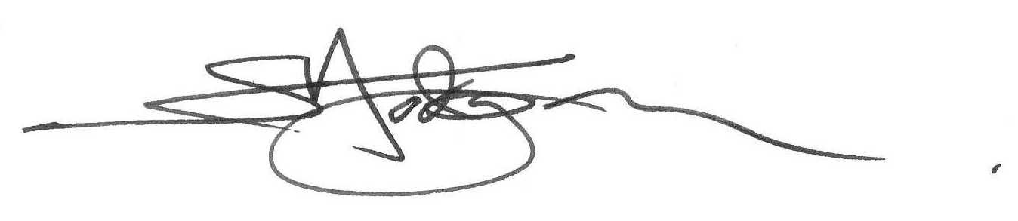

Simon Hodgson
Chief Executive
Forestry and Land Scotland

