Gender Pay Gap Report 2022

What is Gender Pay Gap Reporting
The gender pay gap shows the difference in the average pay between all men and women in a workforce. If a workforce has a particularly high gender pay gap, this can indicate there may be a number of issues to deal with, and the individual calculations may help to identify what those issues are.

The gender pay gap is different to equal pay. Equal pay deals with the pay differences between men and women who carry out the same jobs, similar jobs or work of equal value. It is unlawful to pay people unequally because of gender.

This report is a snapshot of our pay and gender as of 31 March 2022, and fulfills Forestry and Land Scotland’s reporting requirements under the Public Sector Equality Duty.
Results & Interpretation

 | Mean Hourly Wage | Median Hourly Wage
Female | £16.51 | £15.55
Male | £16.24 | £14.17
All staff | £16.34 | £15.01
Gender Pay Gap | -1.7% | -9.7%

Percentage of Headcount in each Pay Quarter
 | Lower | Lower Middle | Upper Middle | Upper
Female | 40% | 21% | 40% | 38%
Male | 60% | 79% | 60% | 62%

Both the median and the mean hourly rates show a negative gender pay gap, with a slight increase in the pay gap since 2021. A reason for this is that there are more women in national office functions compared to other parts of the organisation. These business areas have more roles with higher pay bands.

The percentage of headcount by pay quarters show us the spread of men and women throughout the organisation by pay. The lower quarter of staff comprises 40% female staff and the upper quarter comprises 38%. This compares with the wider FLS population of 35% women. The number of women in the organisation as a whole, as well as the number of women in the upper quarter have both increased since last year.

Actions we are taking to create gender balance
Forestry and Land Scotland supports the fair treatment and reward of all staff irrespective of gender. We have pay and conditions of employment that do not discriminate unlawfully and are free from bias by ensuring that equal pay is in place for like work, work rated as equivalent and work of equal value.
These are specific actions we are taking to create gender balance in the workplace:
- Continuing to be transparent with salary ranges, gender pay gap, pay bands and benchmarking
- Removing unnecessary criteria from job descriptions, and analysing the use of gendered language in our job adverts so that wording is gender-neutral
- Using positive action in recruitment in areas where women are under-represented
- Equality and Diversity training is compulsory for all our workforce, which they must refresh each year
- Committing to flexible working practices
- Introducing Menopause Guidance to support staff going through menopause, as well as their colleagues and managers.
- Engaging the Bystander training to empower staff to challenge inappropriate behaviour in the workplace.

I confirm that the data reported and the calculations produced are accurate.

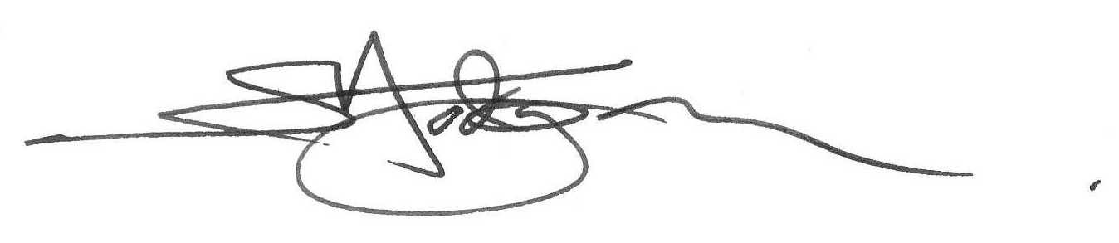
Simon Hodgson
Chief Executive, Forestry and Land Scotland

