Gender Pay Gap Report 2021

What is the Gender Pay Gap?
The gender pay gap shows the difference in the average pay between all men and women in a workforce. If a workforce has a particularly high gender pay gap, this can indicate there may be a number of issues to deal with, and the individual calculations may help to identify what those issues are.

The gender pay gap is different to equal pay. Equal pay deals with the pay differences between men and women who carry out the same jobs, similar jobs or work of equal value. It is unlawful to pay people unequally because they are a man or a woman.

This report is a snapshot of our pay and gender as of 31 March 2021, and fulfills Forestry and Land Scotland’s reporting requirements under the Public Sector Equality Duty.
Results & Interpretation

 | Mean Hourly Wage | Median Hourly Wage
Female | £16.13 | £15.09
Male | £15.96 | £13.80
All staff | £16.02 | £14.56
Gender Pay Gap | -1.1% | -9.4%

Percentage of Headcount in each Pay Quarter
 | Lower | Lower Middle | Upper Middle | Upper
Female | 40% | 19% | 37% | 35%
Male | 60% | 81% | 63% | 65%

The gender pay gap is calculated using the median and mean hourly wages:
- Mean hourly rate is calculated by adding all hourly rates and dividing this by the number of staff in the group. The mean is affected by small numbers of very high or very low earners.
- Median hourly rate is calculated by lining up all the hourly rates in the group from lowest to highest, and identifying the rate in the middle. The median is unaffected by small numbers of very high or very low earners.
Both the median and the mean hourly rates show a negative gender pay gap.

The percentage of headcount by pay quarters show the spread of men and women throughout the organisation by pay. The lower quarter of staff comprises 40% female staff and the upper quarter comprises 35%. This compares with the wider FLS population of 33% women. An area of blockage is the Lower Middle quarter, where there are just 19% women.
Actions we are taking to create gender balance
Forestry and Land Scotland supports the fair treatment and reward of all staff irrespective of gender. We have pay and conditions of employment that do not discriminate unlawfully and are free from bias by ensuring that equal pay is in place for like work, work rated as equivalent and work of equal value.

These are specific actions we are taking to create gender balance in the workplace:
- Removing unnecessary criteria from job descriptions, with support from Equate
- Ensuring there is gender balance on all recruitment panels
- Using a structured interview process for all our vacancies, with a competency-based framework. We also anonymise our applications to guard against any unconscious bias from recruiting panels.
- Continuing to use transparent promotion, pay and reward processes. For example, there is senior sign off for non-standard pay progression amounts.
- Our pay negotiation is carried out on a corporate basis with our trade unions, rather than an individual basis. All our salary points are published on our intranet and are visible to all our staff. The relevant salary points are included in job adverts.
- Equality and Diversity training is compulsory for all our workforce, which they must refresh each year.

I confirm that the data reported and the calculations produced are accurate.
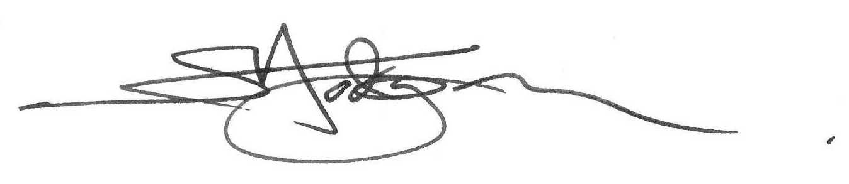
Simon Hodgson
Chief Executive, Forestry and Land Scotland

